Operating Systems and Networks 159.342

Assignment 2 due: 14th of May

Cryptography: RSA algorithm with Cipher Block Chaining

Secure Communication Protocol
In this assignment your task is to implement a hybrid encryption algorithm called RSA with Cipher Block Chaining for communicating TCP client-server applications. You are not allowed to use any third-party libraries that implement network security protocols and algorithms (e.g. OpenSSL, GMP, etc.), or other toolset with built-in cryptographic functions (e.g. Qt), etc. except for Boost https://www.boost.org/. You need to implement the RSA and CBC algorithms in C/C++ from scratch.

In the TCP client-server examples, as you might remember, a client types a message, and then sends it to a server. In turn, the server echoes back the message. In this assignment, you have to modify the client so that it encrypts all messages sent to the server. In addition, you also have to modify the server, so that it decrypts the encrypted message locally.

Below are the basic steps describing the secure communication protocol.

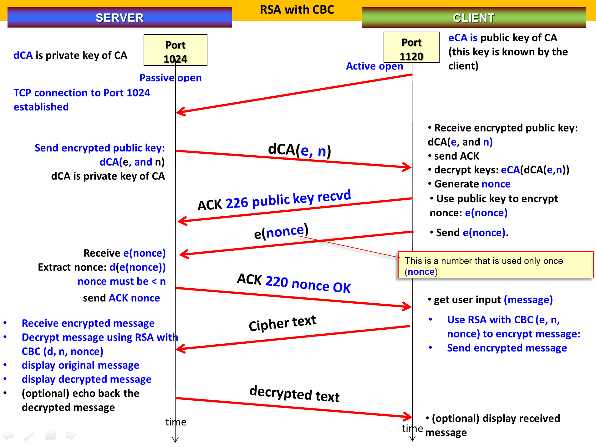

Create a fixed RSA private key (dCA) and public key (eCA) for a CA (certification authority).
Assume that the CA issued a certificate for a server, containing its public key. That means the server has dCA(e,n). This is an encrypted public key of the server. Assume further that the client knows the public key of the certification authority (eCA), who issued the certificate.

Note: In this assignment, there is no commercial CA involvement. We will only make our own dCA(e, n) and eCA.

As always, the server must be up and running prior to a client connecting to it.
After the server accepts a client connection request, establishing a TCP connection, the server must send the client its encrypted public key dCA(e,n). In turn, the client extracts the public key using its copy of the certification authority’s public key: eCA(dCA(e,n)), then ACKs the receipt of the key. Next, the client informs the server of the random number (nonce) that will be used for the initial encryption and decryption operations. This nonce is sent encrypted using e(nonce). Successive messages coming from the client will then be encrypted accordingly using RSA-CBC, and the server will decrypt the received messages using RSA-CBC. The server may also echo back to the client the decrypted messages (this is optional - not required).

The client/server must be able to show the original, encrypted and decrypted messages, as seen in the example below:

- The client types: hello

- The server prints locally: The received encrypted message was: 10898 15630 8308 321 13772 22674 22040
After decryption, the message found is: hello
Design issues
There are many details in the implementation of a real RSA with Cipher Block Chaining that might have to be left out in order to keep it under the scope of an assignment. You have to ask the following questions regarding some decisions about the implementation:

a) What are the sizes of the keys? (aim for a big number(in the thousands) for the variable n in RSA)
b) Should the encryption be done character by character, or by block of characters?
c) Should padding be used?
d) Do you need an arbitrary precision library, or the keys are small enough to use a simple exponential code?
e) How are the keys sent to the client (your protocol design should specify: format, message order, etc).

The answers to these questions will establish how your own “encryption protocol” works.

For more details, check out the following documents:
- The details of the core algorithm that must be implemented can be found in “Week_06_Network_Security_Implementing RSA_CBC_v2.pptx” You are allowed to use relatively small prime number pairs, but do not use pairs that will generate the same original message after encryption.
- Use the cross-platform start-up codes provided for Assignment #2. I have separated the start-up codes for Windows and Unix-based based systems, but their only differences are the makefile, run.bat (for Windows) and run.sh (for Unix) files. Modify these source codes for your implementation of the secure communication protocol.

For verification and accurate marking of the assignment, the following information must be displayed on screen, as part of the secure server and secure client implementations.
Secure Server:
- Print on screen the secure server’s:
  - Public key (e, n)
  - Private key (d, n)
  - Certificate issued by a Certification Authority (CA) – make your own d_{CA}(e,n)
- Print on screen the received encrypted NONCE e(NONCE).
- Print on screen the decrypted NONCE d(e(NONCE)).
- Once the NONCE is correctly decrypted, print on screen the ACK transmitted to the client
  - ACK 220 nonce ok.
- During the communication session:
  - Print the encrypted message received from the client.
  - Print the decrypted message after applying RSA-CBC.

Secure Client:
- Print on screen the received certificate from the secure server:
  - d_{CA}(e,n)
- Print on screen the decrypted certificate from the secure server:
  - e_{CA}(d_{CA}(e,n))
- Print on screen the ACK transmitted by the client once it has decrypted the certificate of the server successfully.
  - ACK 226 public key received.
- Print on screen the NONCE.
- Print on screen the encrypted NONCE e(NONCE).
- Print ACK transmitted by the client once it has encrypted the NONCE successfully.
  - ACK 226 public key received.
- During the communication session:
  - Print the plaintext message.
  - Print the encrypted message (using RSA-CBC).
Restrictions:
- Big Number Library: You may only the Boost C++ library for implementing big numbers in your cryptographic method. No other libraries are allowed (i.e. GMP library is not allowed)
- OpenSSL (or other libraries with built-in cryptographic functions) is not allowed in this assignment as students are expected to learn how to implement the core algorithms from scratch.
- The cross-platform start-up code compiles and runs on both Windows and Unix-based systems but the assignment will be marked only in a Windows environment.
Testing the assignment:
For quickly testing the assignment, use the batch file, run.bat or run.sh (for unix-based systems) provided.
The assignment will be marked based on functionality, design and correctness.

The marks are distributed as follows:
- 1 mark: for correctly creating and sending of the encrypted RSA public key to the client. The client must also decrypt the public key correctly.
- 1 mark: for correctly sending the encrypted random number (encrypted(nonce)) to the server, as well as decrypting and extracting the nonce correctly.
- 2 marks: for correctly creating and sending the certificate of the server d_{CA}(e,n). In turn, the client must be able to receive, decrypt and extract the server’s public key correctly.
- 8 marks: for the correct implementation of RSA with Cipher Block Chaining. The encryption/decryption results should always be correct for any ASCII characters. Make sure that the combination of the selected RSA keys and nonce will not have any problem encrypting and decrypting messages.
- 3 marks: Documentation (MS Word). Submit an accomplished Checklist (fill-up the given check list form that comes with this document).
Write a brief description of your system (i.e. specify the message format, encoding, decoding scheme, how keys are sent, generation of keys, etc.).
Provide snapshots of three complete client/server interactions, using the following test input strings:

For testing, use the following test input strings:
- “the quick brown fox jumps over the lazy dog.”
- “AAA”
- “555”

- *Bonus marks (max. of 2 marks) will be given to those who can implement and utilise correctly the boost library’s big number support, to allow for very large public and private keys (make a note in your assignment submission if you did this. Boost: https://www.boost.org/

Notes:
1 - Submit your files electronically via Stream, in zip format. Submit everything, including the folders, make files, batch file, project support files, check list, snap shots and brief documentation of your system. If you are using a special big number library, you should document that, too. Everything should compile in a Windows platform for marking.
2 - This assignment is worth 15 marks (+ bonus, if your submission qualifies).
3 - Marks will be subtracted for obvious copying and/or for delays without justification.

Checklist (Include this in your submission)
Please accomplish the following check list in order to allow for accurate marking of your assignment.

 | Item | your assignment details |  |  |  |  | Comments
1 | Names and ID numbers of Group Members |  |  |  |  |  | (Maximum of 3 members in a group)
2 | Operating System(s) used for testing your client and server codes | Windows 10 |  |  |  |  | Note: The cross-platform assignment will be marked using Windows 10.
3 | Compiler used | g++ 12.2.0 |  |  |  |  | g++ 12.2.0 is required. Your program will be compiled and marked using this.
4 | IDE used | If using Visual Studio, you need to submit the complete project files (all supporting files required).
5 | Files: Have you submitted all the files required to compile your codes and test it? Include the makefile/CMakeLists.txt, *.cpp, *.h, *.sln, .vcxproj, etc. | Yes/No |  |  |  | Indicate ‘Yes’ or ‘No’. Make sure that you submit all the supporting files if you developed your codes using CLion or Visual Studio.
6 | Required Functionalities | Sending encrypted RSA public key to the client, and decryption of the public key by the client |  | full/partial/none |  |  | Indicate ‘full’, if you have completed the implementation of the required command, ‘partial’, if you are only submitting a partial implementation, or ‘none’, if not accomplished.
6 | Required Functionalities | Sending encrypted nonce to the server, and decryption of nonce by client |  | full/partial/none
6 | Required Functionalities | RSA with Cipher Block Chaining |  | full/partial/none
7 | Cryptographic keys | Write the public and private keys used by the server and the server’s Certification Authority. Also include the NONCE used by the server and client.
Certification Authority |  | Write the keys below.
 |  | CA Public key (e_{CA}, n_{CA})
 |  | CA Private key (d_{CA}, n_{CA})
Secure Server
 |  | Public key (e, n)
 |  | Private key (d, n)
 | Secure server’s certificate issued by the CA | d_{CA}(e,n)
 | Number that is used only once, as part of CBC | NONCE
8 | Snap shots of sample interactions, encryption and decryption: one for each required test input. | Indicate ‘full’, if your codes can encrypt the following test inputs and then decrypt them correctly, snap shots must be included; ‘partial’, if your codes can only solve them partially (not all characters can be encrypted, then decrypted back to their original form), snap shots must be included; write ‘none’, if they are not solvable by your codes.
8 | Input containing all letters of the alphabet | Test Input #1: the quick brown fox jumps over the lazy dog | full/partial/none |  |  |  | Must include snap shots
8 | Input with repeating characters | Test Input #2: AAA | full/partial/none |  |  |  | The encrypted message must not exhibit any repeating pattern as cipher block chaining addresses this problem. Show snapshots.
8 | Input with repeating characters | Test Input #3: 555 | full/partial/none |  |  |  | The encrypted message must not exhibit any repeating pattern as cipher block chaining addresses this problem. Show snapshots.
9 | Extra work done (Max. bonus of 2 marks) | The submitted program uses the Boost library’s big number facility. Very large public key and private keys are used to implement RSA-CBC. |  |  |  |  | Yes/No
 |  | Includes a makefile for building the program with Boost library. |  |  |  |  | Yes/No

---
Nothing follows.

